PC Ma 12 Quadratic Functions
Review – key
BLM 3–5 Section 3.2 Extra Practice
1. a) Yes. The function fits the standard form of a quadratic function with a = 1, b = –15, and c = 0.
b) y = x² – 16 Yes. The function fits the standard form of a quadratic function with a = 1, b = 0, and c = –16.
c) Yes. The function fits the standard form of a quadratic function with a = –4.9, b = 0, and c = 400.
d) No. The function does not fit the standard form of a quadratic function.
2. |  | a) | b)
 | Vertex | (–1, –4) | (–1, 9)
 | Axis of symmetry | x = –1 | x = –1
 | x-intercepts | –3 and 1 | –4 and 2
 | y-intercept | –3 | 8
 | Direction | upward | downward
 | Max/min | min y = –4 | max y = 9
 | Domain | x ∈ R | x ∈ R
 | Range | y ≥ –4 | y ≤ 9
3. a) y = x² + 14x + 39 b) f (x) = –6x² – 3x + 30
c) h(t) = –9t² – 18t + 41 d) y = 8x² + 26x + 15
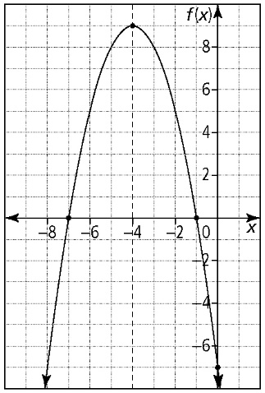
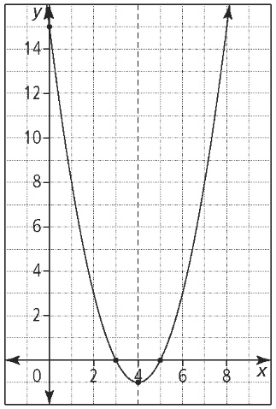
4. a) b)

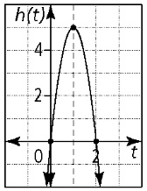
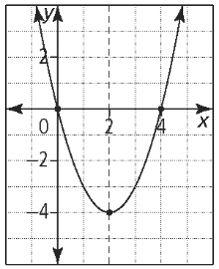
c) d)

 | a) | b) | c) | d)
Vertex | (4, –1) | (–4, 9) | (2, –4) | (1, 5)
Axis of symmetry | x = 4 | x = –4 | x = 2 | t = 1
x-intercepts | 3 and 5 | –1 and –7 | 0 and 4 | 0 and 2
y-intercept | 15 | –7 | 0 | 0
Direction | upward | downward | upward | downward
Max/min | min: –1 | max: 9 | min: –4 | max: 5
Domain | x ∈ R | x ∈ R | x ∈ R | t ∈ R
Range | y ≥ –1 | f (x) ≤ 9 | y ≥ –4 | h(t) ≤ 5

5. a) w = width; 2 width + length = 200 m of fencing, so length = 200 – 2w
b) A(w) = w(200 – 2w) or A(w) = –2w² + 200w
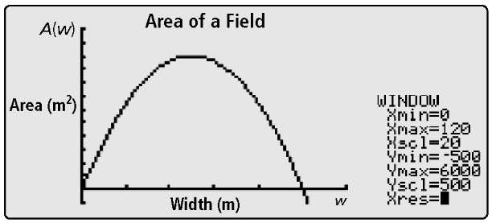
c)

d) 5000 m² e) 50 m by 100 m
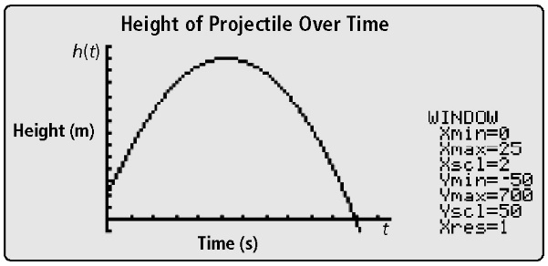
6. a)

b) 100 m; this represents the initial height of the projectile
c) 21.9 s; this represents the time that the projectile is in the air
d) 651.25 m; occurs at 10.5 s

