**PC Ma 12 Quadratic Formula Review (lesson 1) key**

**BLM 4–7 Section 4.4 Extra Practice**

**1.** **a)** two real roots **b)** no real roots **c)** one real root **d)** no real roots

**2.** **a)** none **b)** 1 **c)** 2 **d)** 2

**3.** **a)** 5 ±  **b)**  **c)**  **d)** 0, 

**4.** **a)** 0.50, 0.33 **b)** no solution **c)** –0.59, 2.26

**d)** –4.46, 1.12

**5.** **a)**  **b)**  **c)**  **d)** 

**6.** **a)** No solution;

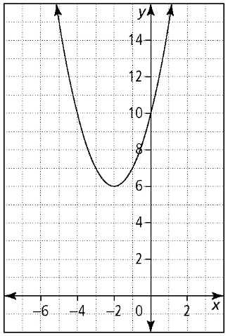

**b)** 0, –7; Factor method: can be factored quickly because *x* is a common factor

**c)** Factor method: a perfect square trinomial

**d)** Complete the square method: already in the form (*x* + *a*)2 = *b*

**e)** Quadratic formula: exact values are required for the answer

**7.** **a)** –3 **b)** 